Gesner Street News


June 2025 Edition

GECKOS Focus in June
During the month of June, we will be reviewing all of the GECKOS focuses:
G-Growth
E-Encouragement
C-Compassion
K-Kindness
O-Optimism
S-Show respect and responsibility

Indigenous Peoples Month
June is Indigenous Peoples month. We will be learning about the indigenous culture throughout the month of June. National Indigenous Peoples Day is June 21st.

A Treat for Our Students
On Thursday, June 5th, we will be having a Play Day for our students. Students will take part in different activities that promote learning outcomes from the physical education program. Since our amazing students have worked hard and successfully met our WIG (Wildly Important Goal) we will have a bouncy castle during our special Play Day! As part of our Play Day, students may have a popsicle.
On June 13th, we are going to be giving all students a taste of our popcorn. Yum, yum!

Grade Two Students Visit to Summerhill & Hubbard
Grade 2 students entering grade 3 at Summerhill in the Fall will have an opportunity to go over for a visit on June 3rd, 11:00-11:30 AM to meet the staff and see the school. Students entering grade 3 at Hubbard will have an opportunity to participate in a Welcome to Hubbard event on June 6th, 9:30-10:00 AM.
As a school community, we have benefited greatly from our wonderful grade two students. They have proven to be dedicated scholars, leaders for the younger students and kind citizens. We wish them well in their new schools. Come back to visit often!
Gesner Volunteers
We will be having a special volunteer celebration in our gym on June 6th, 9:30 AM to show how appreciative we are for all your help throughout the school year.

You’re Invited!!
Our school’s Parent School Support Committee (PSSC) is recruiting new members. Join us on Thursday, June 12th, 6-7 PM at the school to see what it is all about. All are welcome! There will be door prizes and treats!

Keeping Safe in the Sunshine
Students are encouraged to wear sunscreen each day to protect themselves from the sun’s rays. If it is applied at home before school, we ask that students also reapply sunscreen at school before each recess for optimum protection. Please help them practice applying it.
Gesner Celebrates Dedicated Dads and Other Special Folks
We want to send a special greeting to all of the wonderful Gesner parents/guardians as they celebrate Fathers’ Day this month. Our students are fortunate to have such caring and dedicated supports.
End of Year School Spirit Theme Week
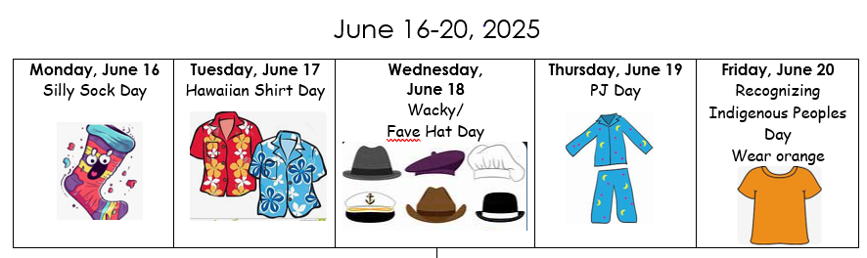
Returning in the Fall
Changes to Our School Day:
-School day will begin at 8:20 AM
-Dismissal: Mon.-Fri.-2:30 PM. Please note we will be in school the whole day on Fridays.
Meet the Teacher
Meet the Teacher night will be held on Thursday, August 28th, 6:00 PM prior to school beginning. You are welcome to visit the classrooms and meet the teachers.
June – Mindfulness Moment
Try deep breathing with your child.
Taking a few deep breaths can make you feel calm and focused.
Here is a great video to get you started:
https://www.youtube.com/watch?v=SmLnUdUea5k
Last Day of School
Our students’ last day of school will be Friday, June 20th with our usual dismissal at 12:25 PM. On this day, students will receive their year-end report card. If students are unable to attend school on this day, parents are asked to provide a self addressed, stamped envelope so that report cards can be mailed.
Teddy Bear Picnic
In response to feedback from parents and staff, we’ll be celebrating with a school-wide Teddy Bear Picnic during lunchtime on Wednesday, June 12, instead of a family picnic this year. Please send your child with 1) A teddy bear or stuffed animal that fits in their backpack. 2) A towel or blanket to sit on.
Summer Wishes
On behalf of the Gesner staff, best wishes for a wonderful summer holiday. It has truly been a joy to work and learn with our amazing students this year.

Dates to Remember:
June
3rd | Grade 2 visit to Summerhill School
4th | Oromocto Public Library Visit-Mme. Bishop’s Class
5th | -Play Day  -Oromocto Public Library Visit-Mrs. Balram’s and Miss. Love’s Classes
6th | -Gesner Volunteer Celebration  -Grade 2 visit to Hubbard School
9th | Grade 1 Kings Landing Field Trip
10th | FI Jeunesse Musicales Presentation at Arc-en Ceil School
11th | K Kings Landing Field Trip
12th | -School Wide Teddy Bear Picnic  -Come at 6:00 PM to see what the PSSC is all about
13th | -Career Day  -Popcorn Day for Everyone
16th | Grade 2 Kings Landing Field Trip
17th | Possible Splash Pad Day
18th | Grade 2 Picnic with Special Treats
19th | Oromocto Public Library Visit-Mme. St. Peter’s and Miss. Foster’s Classes
20th | Last day for students/ Report Cards Go Home
August
28th | Meet the Teacher at 6 PM

School Website:
https://ge.nbed.ca/
Gesner Facebook:
https://www.facebook.com/Gesner-Street-Elementary-School-114945196991019
Gesner X: @GesnerStElemen1
Gesner Instagram Account: @gesnergecko

