Gesner Street News


April 2025 Edition

Show Respect: GECKOS Focus for April
This month students will be learning about showing respect. This means making good choices, having control over our thoughts and actions, practicing good habits, being patient, controlling our temper and taking responsibility for our actions.
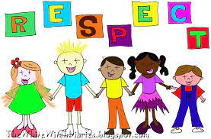
Also, to work on our Growth Mindset, the April Monthly Mantra at school is “There’s a difference between not knowing and not knowing yet!”
Click on the link below to see a video: https://www.youtube.com/watch?v=XLeUvZvuvAs
Reports Cards go home on April 7th
Students will receive their report cards on April 7th. Parent teacher conferences will be held during the afternoon and evening of April 10th and morning of April 11th. Teaching staff will be involved in professional learning during the afternoon of April 11th. Students do not attend school on April 11th.

Have You or Your Neighbor Registered for Kindergarten Fall 2025?
We are in the process of staffing our schools for Fall 2025. If you have a friend, neighbor or yourselves please call the school and we can direct you on how to register for school.
Gesner’s Online Auction
Our school's online auction will be live from April 7th to 17th! A big thank you to all the businesses and individuals who generously donated items. We also want to express our gratitude to our parent volunteers for their hard work in organizing the event. Happy bidding, everyone!
Insert Facebook Link
Scholastic Book Fair
Our next book fair is coming soon, April 22-26. We will be reaching out for volunteers to help with the Scholastic Book Fair. Your support is greatly appreciated. More details to follow.

Swing Into Spring at Gesner
We are having a spring event with a craft fair, Scholastic Book Fair and lots more!

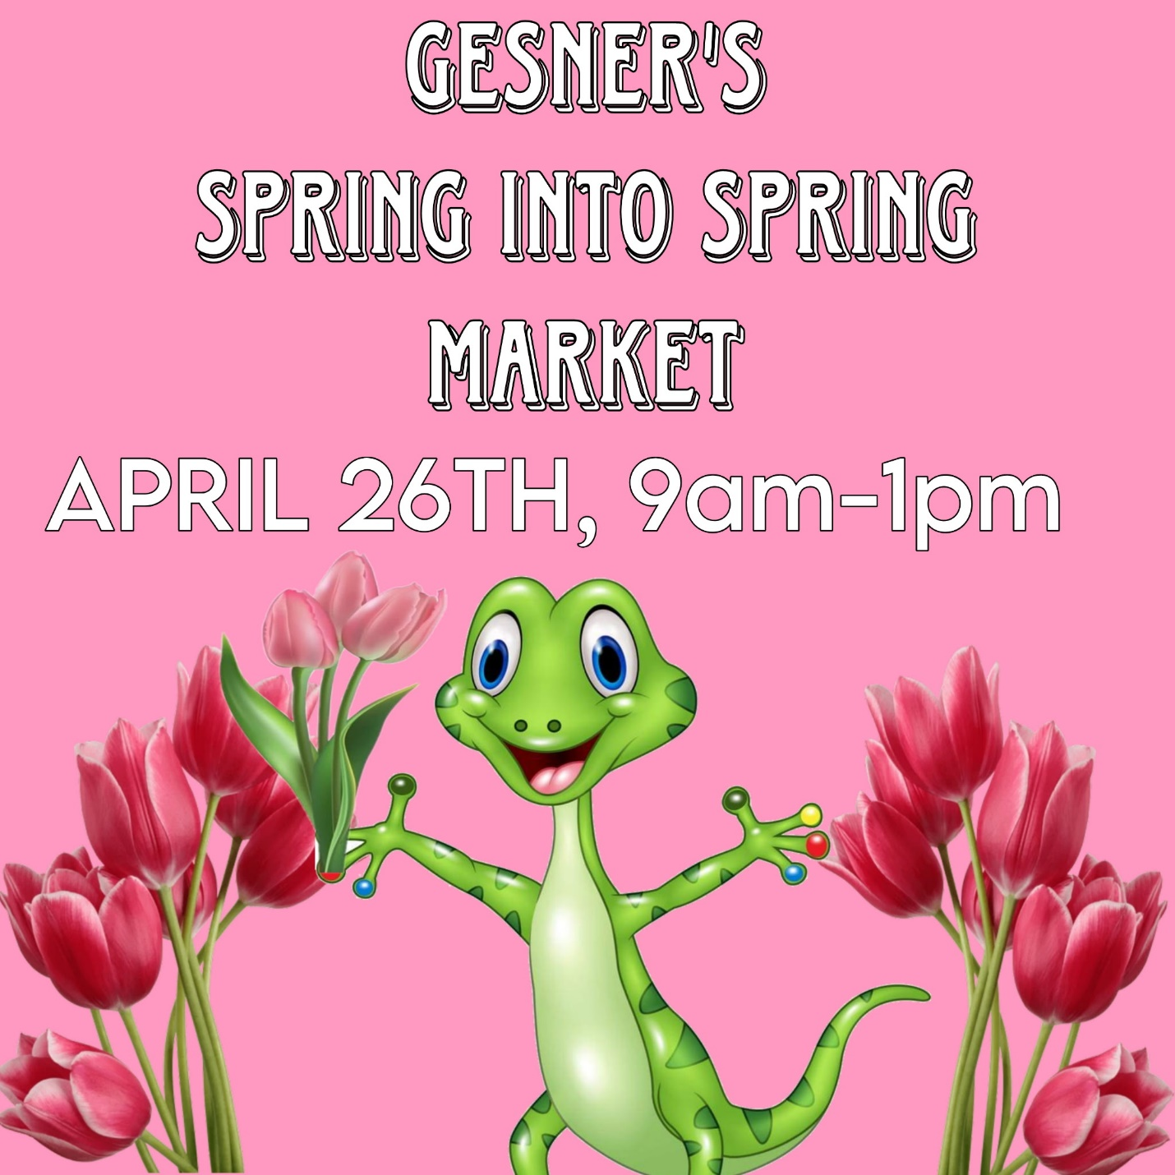

Parent School Support Committee
The next meeting of our Parent School Support Committee will be held on April 17th at 6:00 PM. This meeting will be an in-person meeting, but attending virtually is an option too. Everyone is welcome to attend.

Field Trip
Throughout April, our classes will be visiting the recycling center at the Fredericton landfill site. Please refer to the list of important dates below to find out when your child’s class will be attending.

Earth Rangers
Earth Rangers will be visiting our school on April 9th. They are an organization focused on environmental education and conservation for children. The goal is to educate children about environmental issues and mobilize them to take actions that protect animals and the environment. During the assembly there will be live animal presentations. See the link below for more information.
https://www.earthrangers.com/EN/CA/


Weather is a Surprise This Time of Year
This time of year, there are lots of puddles that lead to wet footwear, socks, and other clothing. Please send in extra clothing for your children. Remember to dress your child in layers so they are prepared for the weather.

Important Dates:
April
1st | K Field Trip to the Recycling Centre
7th | Report Cards Go Home
8th | Grades 1 & 2 FI Field Trip to the Recycling Centre
9th | Earth Rangers Assembly
10th | Parent Teacher conferences in the afternoon and evening.
11th | Parent Teacher conferences in the morning. Professional learning for teaching staff in the afternoon. No school for students.
15th | Grades 1 & 2 English classes - Field Trip to the Recycling Centre
18th | Good Friday, No School
21st | Easter Monday, No School
22nd | Earth Day
22-26 | Scholastic Book Fair
26 | Gesner’s Spring Craft Fair
May
2nd | Subject Council – No School

From the students and staff of Gesner, we wish everyone a great month!

School Website:
https://ge.nbed.ca/
Gesner Facebook:
https://www.facebook.com/Gesner-Street-Elementary-School-114945196991019
Gesner X: @GesnerStElemen1
Gesner Instagram Account: @gesnergecko

