**Gesner Street News**

**March 2025 Edition**

**Thank You for Your Support**   
A heartfelt thank you to all the parents who made this year’s **Staff Appreciation Week** so special! From the delicious treats to the thoughtful notes, your support truly made a difference. We are so grateful for the partnership we share in fostering a positive and encouraging atmosphere for both students and staff. Thank you for helping us honor the incredible staff who make our school a wonderful place for learning and growth!

**GECKOS – March is Optimism Month**

Our March GECKO theme is Optimism!  Having a positive mindset is so important. It helps us solve problems in the right way. Being optimistic allows our brain to grow so we can do anything we put our mind to and helps us feel positive about ourselves when we are trying things that can be hard or new for us. When we try new things and are successful, we feel great about ourselves, and it gives us confidence to try other things that can be challenging. Some things to say to yourself are:

* “I can do it!”
* “Reading is hard for me, but I am getting better every day when I practice.”
* “With more work, I got this.”

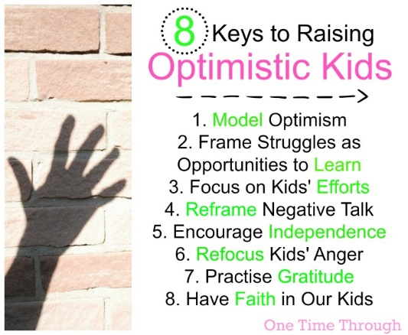

**March is Nutrition Month**

During March, our staff will be sharing information about the importance of good nutrition and how it helps us as learners! 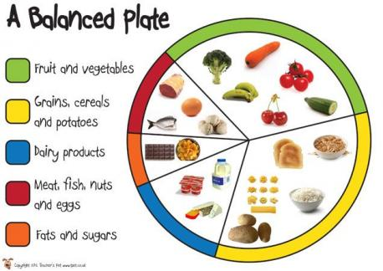

**News From the Parent Volunteer Group**

We are excited to announce that our school will be hosting an online auction! We are seeking new items, including homemade goods, gift certificates, merchandise, and more. If you would like to donate, or if you know of anyone who may be interested in contributing, please don’t hesitate to reach out.You can e-mail [gesnervolunteers@gmail.com](mailto:gesnervolunteers@gmail.com) or phone the school number, 357-4065.

**The deadline for receiving donations is Monday, March 17th**. **The auction will be live Monday, April 7-Thursday, April 17**.

**Theater New Brunswick Young Company Performance**

There will be a school wide performance of ***Tree Boy*** on Thursday, March 20. There are environmental and teamwork themes with their theatrical show.

*Can a 10-year-old boy really help save the environment? When Avery Adamson uncovers a plot by his father to cut down his favourite tree in favour of a parking pad for his new fossil fuel guzzling SPV300, Avery declares an environmental emergency and stages a protest to protect the tree and the planet.*

**Indigenous Drumming and Dancing Performance**

On Tuesday, March 25 we will experience a vibrant celebration of culture, rhythm, and movement as OHS and Hubbard students come together for an unforgettable indigenous drumming and dancing performance. This special event blends the deep traditions of indigenous drumming with dynamic dance, creating an immersive experience.

**PSSC Updates**

The next PSSC meeting will be held April 17th, 6 PM. All parents are welcome to attend.

**School Updates- March 28th**

Teaching staff will be involved in report writing on **March 28th.** Therefore, students do not attend school.

**Report Card Time**

On **April 7th,** students will receive their second report card. Parent teacher conferences will be held during the afternoon/evening of April 10th and in the morning on April 11th. Students will not be attending school on April 11th.More information will follow.

**French Pride Week**

During the week of **March 17-21**, we will be celebrating *French Pride*. Students will have the opportunity to participate in various activities, such as learning about the Acadian flag, sampling croissants and cheese, and French folk dancing. Did you know March 20th is *International Francophone Day*?

**Have a Wonderful March Break!**

|  |  |
| --- | --- |
| **March** |  |
| 3 -7 | March Break |
| 10 | First Day Back After March Break |
| 12 & 19 | K Skating |
| 17-21 | French Provincial Pride Week |
| 17 | * Deadline for Online Auction Donations * St. Patrick Day - Wear Green |
| 20 | TNB Tree Boy Performance |
| 25 | Indigenous Drumming and Dancing Performance |
| 28 | Report Card Writing Day – No school for students |

**School Website:**

[**https://ge.nbed.ca/**](https://ge.nbed.ca/)

**Gesner Facebook:**

[**https://www.facebook.com/Gesner-Street-Elementary-School-114945196991019**](https://www.facebook.com/Gesner-Street-Elementary-School-114945196991019)

**Gesner X: @GesnerStElemen1**

**Gesner Instagram Account:** **@gesnergecko**