Gesner Street News

February 2025 Edition

February is Black History Month
For 2025, Canada’s theme for Black History Month is: Black Legacy and Leadership: Celebrating Canadian History and Uplifting Future Generations. This year’s theme reminds us to recognize the outstanding contributions of Black Canadians, their legacy and promotion of cultural awareness.
Grade 1 French Immersion
Information has been posted on the ASD-W website regarding grade one French Immersion Registration. Please visit the link below.
https://asdw.nbed.ca/current-students/grades-k-12/french-immersion-registration-and-withdrawal/

Valentine’s Day
On Friday, February 14th we will celebrate Valentine’s Day with our students. Classroom teachers will be in touch with parents to inform them of various classroom events. For this day, students are encouraged to wear red, white or pink!

GECKOS Education for February
This month we are focusing on the letter K (for kindness) in GECKOS. Kindness is an important quality to have when growing up. When someone is kind, it means they are considerate and nice to others. Some good examples of kindness are saying please and thank you, sharing, and doing anything that helps others. When you treat other people with kindness, you feel good!

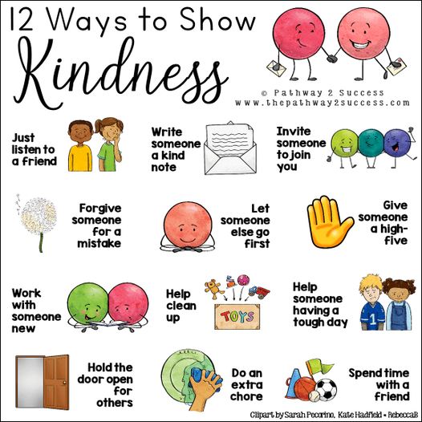

Pink Shirt Day at Gesner
On Wednesday, February 26th, we are celebrating Pink Shirt Day. Students and staff are encouraged to wear pink or white to reflect the importance of joining together in support of respect, kindness, and friendship towards one another. This day originated in Canada and the pink shirt symbolizes a stand against bullying.

Skating Update
Grade one will begin their skating schedule on Wednesday, February 5th. Parent volunteers are greatly appreciated! During our Grade 2 skating sessions we had amazing support from parents and grandparents. Bravo!!!

Family Day in New Brunswick
Monday, February 17th is Family Day for New Brunswick residents. Students do not attend school on this day. Have a wonderful family day everyone!

Staff Appreciation Week
Staff appreciation week will be held from February 10th-14th. Parents may wish to acknowledge the work of those who support their child at school. Thank you, Gesner staff, for all you do for our students!

Parent School Support Committee
The next PSSC meeting will be held on February 13th at 6:00 PM in person, virtually is also an option on Teams. All parents are welcome to attend, just let Mrs. Baker know, so that she can add you to the invite. Everyone is welcome!
Dates to Remember:
February
5th, 12th, 19th | Grade One Skating
10th – 14th | Staff Appreciation Week
13th | PSSC meeting at 6:00 PM
14th | Valentine’s Day
17th | Family Day – no school
18th | Art Richard Concert
20th | National Take Me Outside Day
24th-28th | School Spirit Week
26th | Pink Shirt Day and Assembly
26th, Mar. 12th, 19th | Kindergarten Skating
March
3rd-7th | March Break-No School
10th | First day back after March break

Spirit Week Feb. 24-28
Monday,  Feb.24 | Tuesday,  Feb.25 | Wednesday,  Feb.26 | Thursday,  Feb.27 | Friday,  Feb.28
Hat Day!  Wear your favourite hat today!   | Sports Team!  Wear  your favourite Sport’s Team Clothing!   | Pink Shirt Day Wear your pink or white clothing/ accessories!   | Gesner Gecko Spirit Day  Wear your Gecko clothing or green!   | The LAST DAY of SCHOOL before break!  Wear your PJs today!  

School Website:
https://ge.nbed.ca/

Gesner Facebook:
https://www.facebook.com/Gesner-Street-Elementary-School-114945196991019

Gesner X: @GesnerStElemen1

Gesner Instagram Account: @gesnergecko



