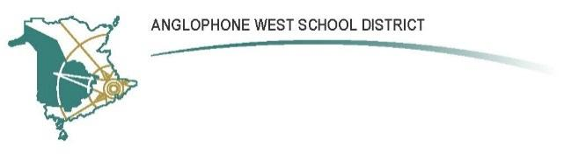

**Gesner Street Elementary School**

**10 Gesner Street, Oromocto, E1V 2S8**

**Parent School Support Committee Agenda**

**Date: February 13, 2025**

**Time: 6:00 PM**

**Location: In Person, Room 131**

**Call to Order:**

**Approval of the Agenda:**

**Approval of the Minutes from the Previous Meeting:**

**Business Arising from the Minutes:**

* **WIG (Wildly Important Goal) Updates-**School wide and classroom
* National Literacy Day January 27th -
* In school literacy activities
* Student Passion Projects

**New Business:**

* **Staff Updates** – Michaela MacAulay (K/1 Teacher) and Seongwoo Park (Phys Ed Teacher) have both been awarded their B Teaching Contracts
* **Nutritional Literacy Grant and French Literacy Grant**-Gesner has been awarded these two grants
* **Staff Appreciation Week**: February 10-14
* **Excellence in Education Award**-Thomas Geburt
* **National Geographic Map**
* **February is Black History Month**
* **Skating at King’s Arrow Arena**
* **Take Me Outside Day-Thursday, Feb. 20th**
* **Pink Shirt Day-Wednesday, Feb. 26th**
* **School Spirit Week-Week of February 24-28**
* **Volunteer Committee Updates-**Online Auction, Spring Market and Scholastic Book Fair

**Correspondence:**

**Closing Comments:**

**Date of Next Meeting: April 17, 2025**

**Agenda for next meeting:**

**Adjournment:**