Gesner Street News 
January 2025 Edition

Welcome 2025!
Best wishes for a healthy and happy New Year from the students and staff of Gesner Street Elementary. Thank you to families for the many cards, gifts, and good wishes during the holiday season. We appreciate all that you do to support your child(ren) at our school.

GECKO Focus
After a break we often need a refresher, so our GECKO focus for the month of January is reviewing our school rules, WITS (when someone is bothering you: W-Walk Away, I-Ignore, T-Talk It Out, and S-Seek Support) and the Zones.
Blue Zone- When children are in the blue zone their body is running slow, such as when they are tired, sick, sad or bored.
Green Zone- When children are in the green zone, their body and brain are ready to learn. This is the zone that students generally need to be in to complete schoolwork and for getting along with others.
Yellow Zone-When children are entering the yellow zone, they are starting to struggle with self-regulation.
Red Zone- When children are in the red zone, they are overwhelmed and unable to manage their emotions and actions, have trouble making good choices, and may be unsafe. Being in the red zone can best be explained by not being in control of one’s own body.

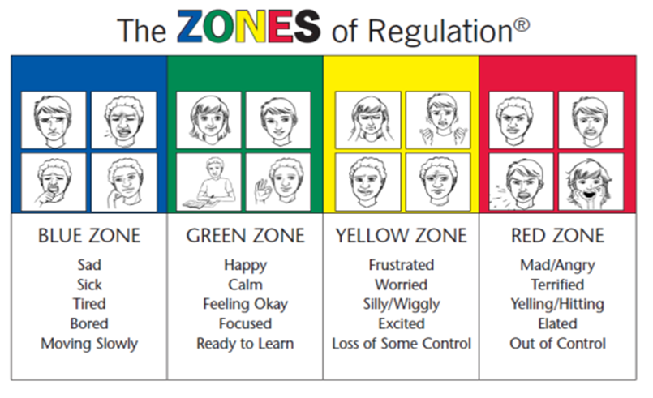

Before Christmas Break students were learning about Keys to Success with the 3G Strong Program. The prefrontal cortex works to decide where to focus attention and what should be a priority.
Awareness of time and energy management, task initiation, working memory, flexible thinking and self-control are executive functions that help us manage daily life.
These skills do not “just happen,” for most elementary students and they have to be practiced. These are life skills that are keys to success.

January’s Frosty Days
When we are back at school, remember to bundle your child up on these very cold days. Packing an extra pair of socks and mittens are a good idea as well, especially because mittens often get wet during the first recess and don’t always have time to dry before the second one. We also go outside in all kinds of weather!
Parent School Support Committee

The next PSSC meeting will be held on Wednesday, January 16th at 6:00 PM. Everyone is welcome!

Parent Volunteer News
Total sales from the Oromocto Galleria winter fundraiser were approximately $650.00. Thank you to all who took part in this and thank you to the Oromocto Galleria in supporting Gesner School!
School-raised funds are used to purchase learning materials, special events for all students, and technology supports. Thank you to families for generously supporting the events at our school.
Family Literacy Day

January 27th is Family Literacy Day. The Theme this year is “Learn to Be Green, Together.” Make a pledge as a family to learn ways to be more green (use less electricity, commute together, and reuse items). Being green together is a fun way to learn as a family while being kind to the environment.

The Family Literacy Day web site is https://abclifeliteracy.ca/all-programs/family-literacy-day for those interested in learning more about this event and activities you could enjoy at home with your children.


Reminder Dates
Happy New Year to Everyone!
From, The Students and Staff of Gesner

January
6th | Students and Staff return to school
15th, 22nd, 29th | Grade 2s skating at King’s Arrow Arena
16th | PSSC meeting at 6:00 PM
17th | Passion Projects – Grade 2s
24th | Passion Projects – Grade 1s
27th | Family Literacy Day
31st | Passion Projects - Ks

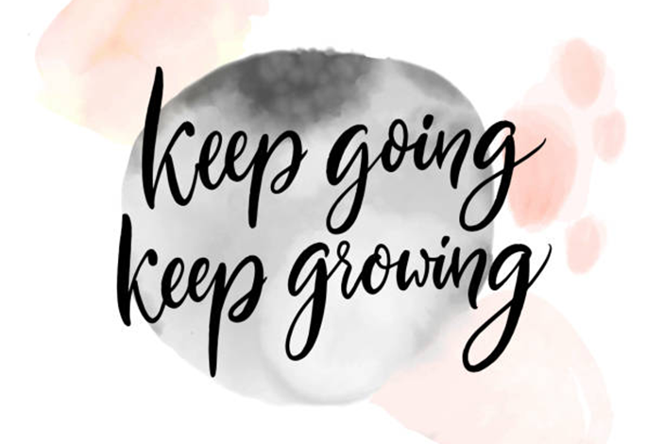
Website:
https://ge.nbed.ca/

Facebook:
https://www.facebook.com/Gesner-Street-Elementary-School-114945196991019

Twitter: @GesnerStElemen1

New Instagram Account!!
Instagram: @gesnergecko

