Gesner Street News

December 2024 Edition

Celebrating the Season
We invite you to join us as we celebrate the spirit of the holidays at our concert on Wednesday, December 11^{th.} There will be two performances: one at 9 AM for A-J last names and a second one at 10:30 AM for K-Z last names. Our talented students, under the direction of Mrs. Hall will perform for families on this special day. If school should be closed on the 11th the backup date is December 18th with performances at 9 AM and 10:30 AM.
As parking is limited, there are some options for visitors. There is a visitor parking lot at the school, but this usually gets full rather quickly. Families can park in the bus lane leaving space for emergency vehicles and there is parking as well on Gesner Street and McLaren. Please do not park on our neighbor’s yards nor in Gesner’s staff parking lot.

Sharing with the Oromocto Food Bank
Each year the Gesner school community takes on a service project to help others. This year, we are collecting items for the Oromocto Food Bank. We are asking guests attending our holiday concert to bring in a non-perishable food item.

Learning to Skate Feels Great!
As an extension of our Physical Education program, Gesner students will have the opportunity to go skating at the Kings Arrow arena several times through the winter months. This opportunity is free of charge for our children and district school buses will provide transportation. More information and a schedule will follow when it gets closer to each grade level’s turn. Even if your child has limited skating ability, they learn quickly at this early age. The school has a limited number of skates and helmets that can be borrowed by our students. Skates and helmets can be great Christmas gifts. Parents, grandparents, and caregivers are always welcome to join us during this time.
Grade 2 students will start skating first, then a few weeks later grade 1 and afterwards the kindergarten students will have a turn.
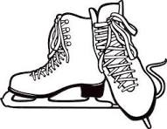

GECKO Learning for December
Our focus is compassion. During this month we will be teaching and talking about caring, sharing, thinking of others, showing concern, helping others, emotional intelligence, empathy and celebrating differences.

Growth Mindset
This month’s Growth Mindset challenge is We Love a Challenge. We will be teaching students about the difference between equity and equality, developing student’s responsibility and set and communicate high expectations of all students.

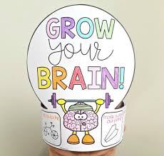

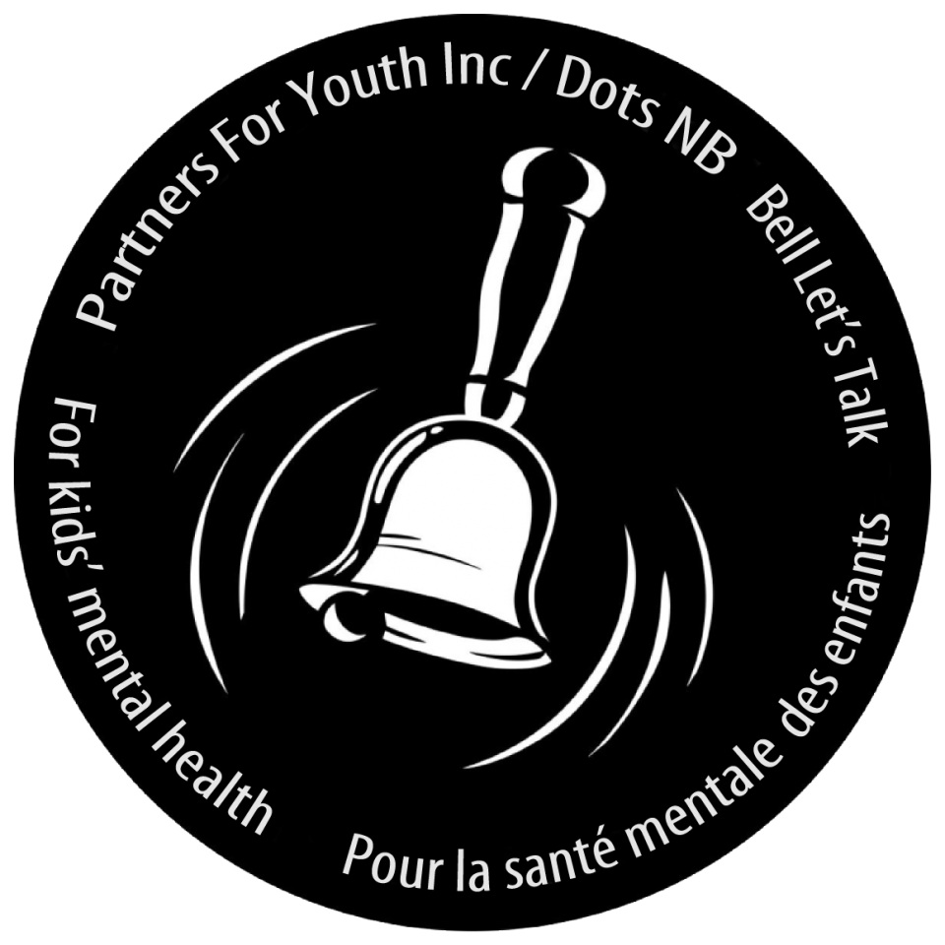
Ring A Bell Campaign
As part of the Dots for Kids Day - Ring a Bell Campaign, students will be learning about mental health and wellness in schools from Dec. 2-5 and, as part of this week, on December 5th here at Gesner, we will be celebrating "Ring a Bell Day." This day is part of a grassroots movement that has been empowering youth, family, and community to take positive actions in support of kids' mental health.

*Just after lunch recess on Dec. 5th we will be making a noise as a whole school with the staff ringing bells to bring awareness to this campaign."

If you would like further information on this day, please check out the following website:
Ring A Bell 2024 – Dots NB

Dates to Remember
The final day for students prior to Christmas break will be Friday, December 20th. Students will return to school on Monday, January 6th.

Website:
https://ge.nbed.ca/

Facebook:
https://www.facebook.com/Gesner-Street-Elementary-School-114945196991019

Twitter: @GesnerStElemen1

New Instagram Account!!
Instagram: @gesnergecko

We wish all Gesner families a peaceful, healthy, joyous holiday season and we look forward to seeing everyone in the New Year.

December
5th | Parent Teacher Interviews PM
6th | No school for students – Parent Teacher Interviews AM
11th | Holiday Concert – storm day 18th
20th | Last day before Holidays.
January
6th | First day back for students after Christmas break.

