Gesner Street News

October 2024 Edition

#### WITS, Zones of Regulation and Our 4 School Rules

This has been our focus for the month of September. Students have been learning about using their WITS when they have a problem.

***School Rules:***

**Rule Number 1**-Safety: Be safe and have fun.

**Rule Number 2**- Interactions: I will be nice to you.

**Rule Number 3**-Achievement: Work and listen carefully.

**Rule Number 4**–Surroundings: Our school and class need to be cared for.

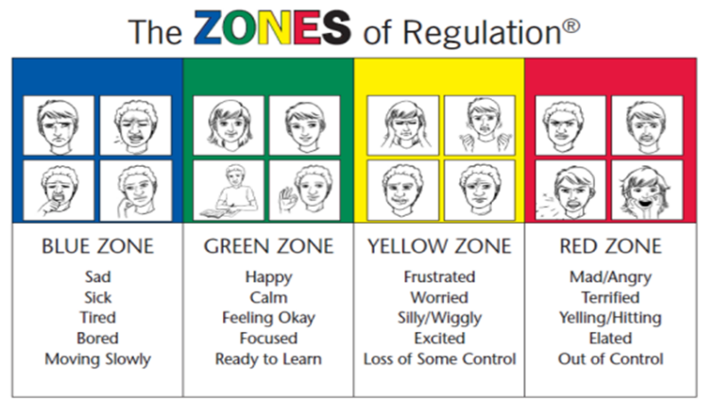

**Kindergarten Registration for 2024-2025** Registration for students entering kindergarten in September 2025 will take place at the school from **October 15th -18th** during school hours. To register a child for kindergarten please register online and we will be booking appointments. When you come to register, please bring:

* Proof of immunization
* Medicare card
* Birth certificate

Feel free to pass this message along to friends and neighbours who have students starting kindergarten next fall.

**Safe Schools Week**

During the week of **October 21st-25th** we will be practicing several safe school routines such as a fire drill, school wide evacuation (we evacuate to Harold Peterson school), lock down and bus safety evacuation. Each year we practice these measures so that our students are well prepared in case we need to use any of our safe school procedures. Teachers will speak with students before the events, so they are well prepared.

**Fire Prevention Week: October 7th-11th**

This year’s fire prevention theme,***Smoke alarms: Make them work for you!*** strives to educate everyone about the importance of having working smoke alarms in the home. We encourage all families to talk about fire safety. The Oromocto Fire Station will be hosting an **Open House on Oct.10th,6:00-7:30 PM**.

**Parent School Support Committee**

The next PSSC meeting this year will be held on **Thursday, October 10th at 6:00 PM.** At this meeting we will discuss the School Improvement Plan and upcoming events. New members are always welcome to attend, and we can offer virtual options so that everyone can attend.

**Parent Volunteer News**

Thank you to parents who have shown interest in helping with the Parent Volunteer group. We're excited to announce our first fundraiser for the 2024-2025 school year. Our "Mabel's Label" fundraiser is as simple as following the link below and then entering "Gesner" into the fundraising field. [Fundraising Support | Mabel’s Labels | Raise Funds With Kids Labels (mabelslabels.ca)](https://can01.safelinks.protection.outlook.com/?url=https%3A%2F%2Fmabelslabels.ca%2Fen_CA%2Ffundraising%2Fsupport%2F&data=05%7C01%7Csheila.baker%40nbed.nb.ca%7C12b101879c4f4bbf848408da999c70b9%7C4d2b5fdfc4d24911870968cc2f465c9f%7C0%7C0%7C637991194435230062%7CUnknown%7CTWFpbGZsb3d8eyJWIjoiMC4wLjAwMDAiLCJQIjoiV2luMzIiLCJBTiI6Ik1haWwiLCJXVCI6Mn0%3D%7C3000%7C%7C%7C&sdata=djcyV2dYx%2FTqddZ%2Fpslw3woI7zrN6lpIVg8rjN3lmdc%3D&reserved=0)

Because of you we can operate our hot lunch program and provide unique learning opportunities for our students. Thank you!

**Eyes and Ears Support our Learning**

If your child has not had their vision or hearing tested recently, consider having these tested. This is an important measure that could make a huge difference in your child’s learning.

**Halloween at Gesner**

On **October 31st** students are invited to wear orange and black to school as we celebrate Halloween. Teachers will contact parents about classroom activities. We do not bring costumes to school.

**Scholastic Book Fair: October 21st-26th**

We are having a bookfair at our school this week. The book fair will also be open during our *Fall into Fall Market*. Your child will have an opportunity to browse the fair and then bring in money to purchase books. This bookfair helps us earn credits to purchase books for our school and classroom libraries.

**Say Cheese!**

Gesner picture day will be Thursday, October 10th.

|  |  |
| --- | --- |
| **October** |  |
| 10 | School Picture Day |
| 14 | Thanksgiving – No School |
| 15-18 | Kindergarten Registration |
| 21 | Fredericton Playhouse Performance-More info to follow |
| 21- 25 | Safe Schools Week |
| 31 | Halloween activities – wear orange and black |
| November |  |
| 5 | Remembrance Day Service at 11 AM-Everyone is welcome to attend. |
| 8 | School Improvement Planning Day-No School |
| 11 | Remembrance Day-No School |
| 22 | Report Card Writing/Professional Learning Day – No School for students |

**Our School Website:**

[**https://ge.nbed.ca/**](https://ge.nbed.ca/)

**Facebook:**

[**https://www.facebook.com/Gesner-Street-Elementary-School-114945196991019**](https://www.facebook.com/Gesner-Street-Elementary-School-114945196991019)

**X: @GesnerStElemen2**