Gesner Street News


April 2024 Edition

Show Respect: GECKOS Focus for April
This month students will be learning about showing respect. This means making good choices, having control over our thoughts and actions, practicing good habits, being patient, controlling our temper and taking responsibility for our actions. We will continue using our WITS at home and at school when practicing respect.
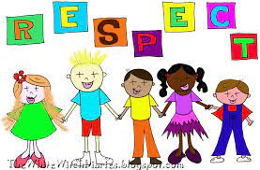
Also, to work on our Growth Mindset, the April Monthly Mantra at school is “There’s a difference between not knowing and not knowing yet!”
Click on the link below to see a video: https://www.youtube.com/watch?v=XLeUvZvuvAs
Solar Eclipse
On April 8, 2024, a spectacular total solar eclipse will be visible in our region. Please note that all schools in ASD-W will dismiss three hours early on April 8th to allow student’s safe arrival at their after-school destinations before the eclipse begins. Our dismissal time will be 11 AM.

It is crucial to ensure that you view the eclipse safely to protect your eyes from harm. NEVER LOOK DIRECTLY AT THE SUN without proper solar viewers! Have a great time enjoying the wonders of the universe as a family and making special memories during this amazing event!

Reports Cards go home on April 11th
Students will receive their report cards on April 11th. Parent teacher conferences will be held the morning of April 15th and during the afternoon and evening of April 18th. Staff will be involved in professional learning sessions during the afternoon of April 15th. Students do not attend school on April 15th.

Parent School Support Committee
The next meeting of our Parent School Support Committee will be held on April 9th at 6:00 pm. This meeting will be an in-person meeting, but attending virtually is an option too. Everyone is welcome to attend.

Matt The Music Man
Matt the Music Man is a multi-award-winning musician! In 2023 he won the ECMA for Children's Entertainer of the Year! Matt promotes self-confidence for kids. He will be performing at our school on Thursday, April 18th. Please see his website for more information: https://www.mattmusic.ca/

Weather is a Surprise This Time of Year
This time of year, there are lots of puddles that lead to wet footwear, socks, and other clothing. Please send in extra clothing for your children. Remember to dress your child in layers so they are prepared for the weather.

Have You or Your Neighbor Registered for Kindergarten Fall 2024?
We are in the process of staffing our schools for Fall 2024. If you have a friend, neighbor or yourselves please call the school and we can direct you on how to register for school.
Swing Into Spring At Gesner
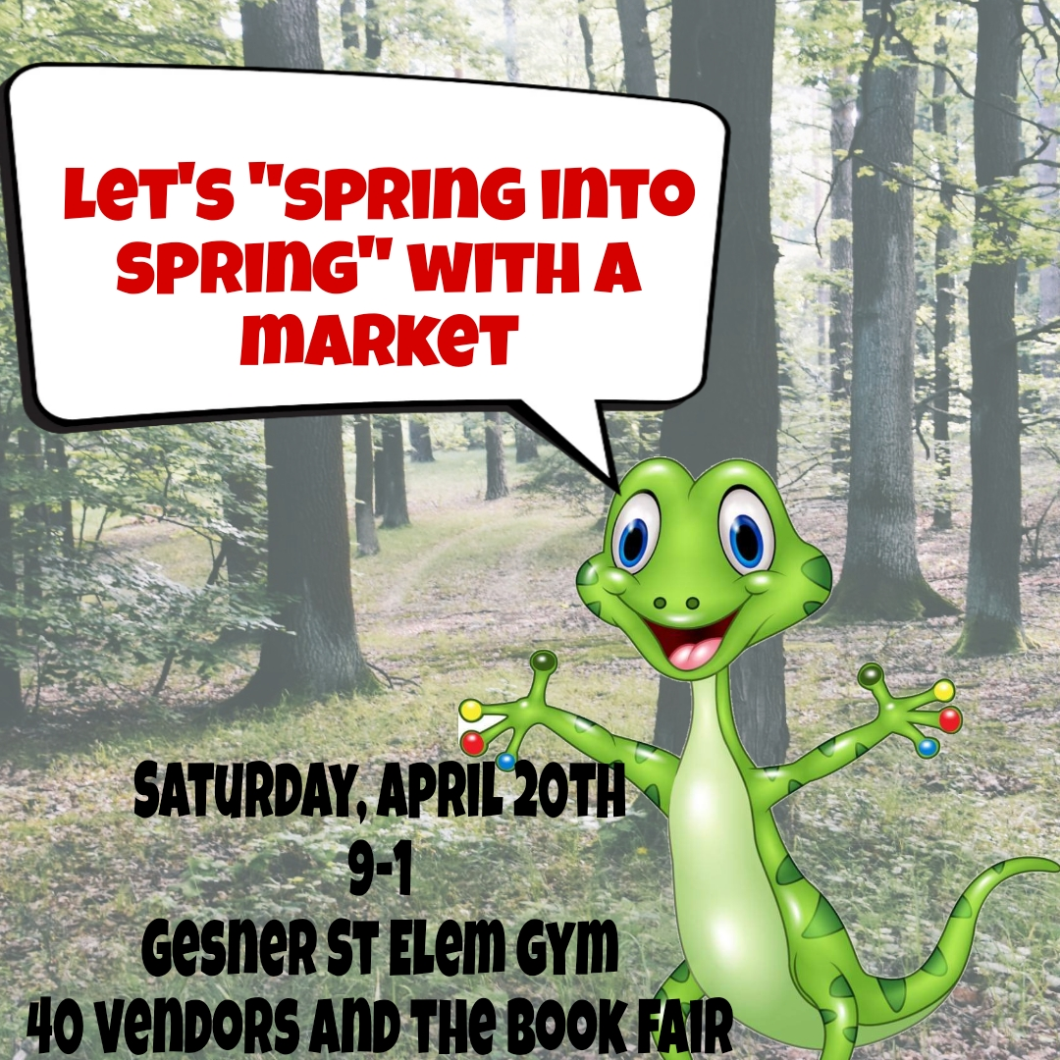
We are having a spring event with a craft fair, Scholastic Book Fair and lots more! More information to follow.

Scholastic Book Fair
Our next Book Fair is coming soon, kicking off on Saturday, April 20th during our Swing into Spring family event, and continuing the following week during school (April 22-26.)
We are looking for a parent volunteer to shadow our volunteer chairperson during this fair and learn the process of running one for next year. If you think you might be interested, please email Stephanie, fajitafanatic@yahoo.com

May School Fundraiser
We are partnering with Pizza Delight to sell pizza combo coupons in May. More information will follow at a later date.

Important Dates:

April
1st | Good Friday
8th | Solar Eclipse, Dismissal 11 AM
10th | K Field Trip to the Recycling Centre
11th | Report Cards Go Home
15th | Parent Teacher conferences in the morning. Professional Learning for staff in the afternoon. No school for students.
17th | Grade 1 Field Trip to the Recycling Centre
18th | Matt the Music Man Performance
18th | Parent Teacher conferences in the afternoon and evening.
20th | Spring Fair, 9-1, Scholastic Book Fair Kick Off
24th | Grade 1 Field Trip to the Recycling Centre-Mrs. Lowe & Ms. Love’s classes
May
1st | Grade 2 Field Trip to the Recycling Centre-Mme. St. Peter, Mrs. Balram and M. Park’s classes
3rd | Subject Council – no school
9th | School Sustainability Study, Meeting #3, Time and Location, TBD
13th | NBTA Branch meeting – no school
22nd | Victoria Day – no school

From the students and staff of Gesner, we wish everyone a great month!

Gesner Website:
https://ge.nbed.ca/
Facebook:
https://www.facebook.com/Gesner-Street-Elementary-School-114945196991019
Instagram: gesnerelementary
X (formerly Twitter):
@GesnerStElemen1

