Gesner Street News

February 2024 Edition

February is Black History Month
For 2024, Canada’s theme for Black History Month is: Black Excellence: A Heritage to Celebrate; a Future to Build. This year’s theme…reminds us to recognize the outstanding contributions of Black Canadians, their legacy and promotion of cultural awareness and pride for future generations.
Grade 1 French Immersion
Information has been posted on the ASD-W website regarding grade one French Immersion Registration. Please visit https://asdw.nbed.ca/current-students/grades-k-12/french-immersion-registration-and-withdrawal/

Valentine’s Day
On Wednesday, February 14th we will celebrate Valentine’s Day with our students. Classroom teachers will be in touch with parents to inform them of various classroom events. For this day, students are encouraged to wear red, white or pink!

GECKOS Education for February
This month we are focusing on the letter for kindness in GECKOS. Kindness is an important quality to have when growing up. When someone is kind, it means they are considerate and nice to others. Some good examples of kindness are saying please and thank you, sharing, and doing anything that helps others. When you treat other people with kindness, both people feel good! February is kindness month.

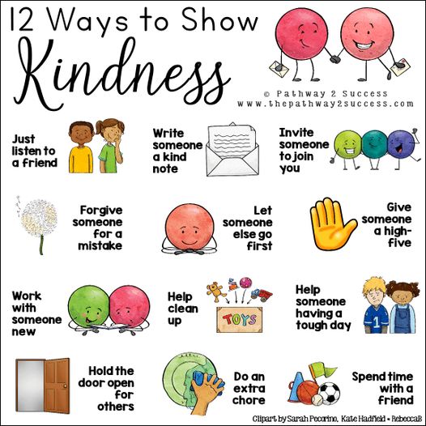

Pink Shirt Day at Gesner
On Wednesday, February 28th, we are celebrating Pink Shirt Day. Students and staff are encouraged to wear pink (or white for peace) to reflect the importance of joining together in support of respect, kindness, and friendship towards one another. This day originated in Canada and the pink shirt symbolizes a stand against bullying.

Skating Update
Grade one will begin their skating schedule on Wednesday, February 7th. Parent volunteers are greatly appreciated!!! During our Grade 2 skating sessions we had amazing support from parents and grandparents. Bravo!!!

Family Day in New Brunswick
Monday, February 19th is Family Day for New Brunswick residents. Students do not attend school on this day. Have a wonderful family day everyone!

Staff Appreciation Week
Staff appreciation week will be held from February 12th-16th. Parents may wish to acknowledge the work of those who support their child at school. Thank you, Gesner staff, for all you do for our students!

Parent School Support Committee
The next PSSC meeting will be held on February 13th at 6:00 PM in person, virtually is also an option on TEAMs. All parents are welcome to attend, just let Mrs. Baker know, so that she can add you to the invite. Everyone is welcome!
Dates to Remember:
February
2nd | Ground Hog Day  Kindergarten Passion Project
7th, 14th, 21st | Grade One Skating
12th – 16th | Staff Appreciation Week
13th | PSSC meeting at 6:00
14th | Valentine’s Day
15th | Flag Day
19th | Family Day – no school
26th -March 1st | Gesner Spirit Week n
28th | Pink Shirt Day and Assembly
28th, Mar 13th, 20th | Kindergarten Skating
March
4th-8th | March Break-No School
11th | First day back after March break

Spirit Week Feb 26-March 1
Monday,  Feb 26 | Tuesday,  Feb 27 | Wednesday,  Feb 28 | Thursday,  Feb 29 | Friday,  March 1
Hat Day!  Wear your favourite hat today!   | Sports Team!  Wear  your favourite Sport’s Team Clothing!   | Pink Shirt Day Wear your pink or white clothing/ accessories!   | Gesner Gecko Spirit Day  Wear your Gecko clothing or green today!   | The LAST DAY of SCHOOL before break!  Wear your PJs today!  

Our School:
Website:
http://web1.nbed.nb.ca/sites/ASD-W/Gesner/Pages/default.aspx
Facebook:
https://www.facebook.com/Gesner-Street-Elementary-School-114945196991019
X (formally-Twitter): @GesnerStElemen1
Instagram: gesnerelementary



