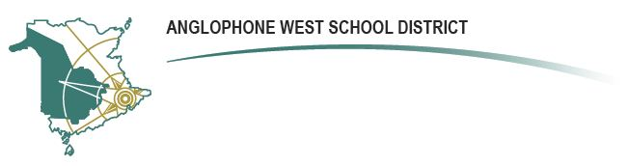

**REGISTRATION PROCESS FOR**

**GRADE 1 EARLY FRENCH IMMERSION AND GRADE 6 LATE IMMERSION PROGRAMS 2024-2025**

**SCHOOL ADMINISTRATORS:**

1. **ASD-W will send, via School Messenger, a voice message on December 8, 2023 to parents/guardians of ALL Kindergarten and Grade 5 students (English Program) informing them of the ASD-W registration process and site for 2024-2025.**
2. Parents who wish to have their child registered in Grade 1 Early French Immersion or Grade 6 Late French Immersion for 2024-2025 are asked to complete the electronic registration form (located on the ASD-W web site: [asdw.nbed.nb.ca](https://asdw.nbed.ca/)) available December 14, 2023. Registrations received by March 1, 2024, will inform planning for the formation of classes for 2024-2025. The registration site will remain open until the end of the school year with scheduled monitoring and updates provided to schools.

If a parent registers and then wishes to withdraw their registration, they would access the same site and click on “*Withdraw from French Immersion Registration*”.

1. If a parent does not have access to a computer to complete the registration form, please have them contact the Administrative Assistant to the Director of Curriculum & Instruction (506-444-4035) to complete the registration. Collect calls will be accepted.
2. Students will be enrolled in the program of selection, unless otherwise notified by the FSL Coordinator for your area. Confirmation emails will be sent to schools in June.
3. A list of students who will be enrolled in the French Immersion Programs will be forwarded to all schools concerned when it becomes available.
4. For additional information about registration for the 2024-2025 school year, contact a French Second Language Subject Coordinator:

***Amanda Desveaux – 506-453-8682***

***Ann Manderson – 506-357-4181***

***Janice Gagnon – 506-325-4567***