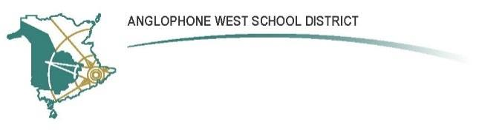

**Gesner Street Elementary School**

**10 Gesner Street, Oromocto, E1V 2S8**

**Parent School Support Committee Agenda**

**Date: November 14, 2023**

**Time: 6:00 pm**

**Location: Gesner School**

**Call to Order:**

**Approval of the Agenda:**

**Approval of the Minutes from the Previous Meeting:**

**Business Arising from the Minutes:**

* Review ideas for calm rooms (PSSC Budget)
  + Costs of items
  + Cost of labour

**New Business:**

* Self-nominations for Co-Chair
* Communication Survey
* Noella’s retirement letter to families
* Resources for families involved with a deployment
  + The Military Family Resource Centre (MFRC) can do a presentation to school staff or to the entire school. We would need to let Kate know if we want to set it up
* Sustainability Study of six elementary and middle schools in Oromocto and Burton Elementary (Letter sent out on Nov 8th)
  + Public consultation meetings
* Possible December Family event

**Correspondence:**

**Closing Comments:** Have a wonderful holiday and see you in the new year!

**Date of Next Meeting: January 16, 2024**

**Adjournment:**