

**Gesner Street Elementary School**

**10 Gesner Street, Oromocto, E1V 2S8**

**Parent School Support Committee Minutes**

**Date: September 19, 2023**

**Time: 6:00 pm**

**Location: Gesner School**

**Attendees:** Sheila Baker, Sherry Jonah, Robyn MacKenzie, Noella Owens, Jolene Hoadley Norquay, Brittany Sinclair, Lisa Bernard, Alison & Andrew Lindsay, and Nolan Gervais

**Virtual Attendees:** Rachael Bertram & Kelly Till

**Regrets:** Thomas Geburt

**Call to Order:** Jolene called the meeting to order.

**Approval of the Agenda:** Sherry approved the agenda, Joy seconded

**Approval of the Minutes from Previous Meeting:** Sheila approved the minutes and Robyn seconded

**Business Arising from the Minutes:**

* **Plan to complete the hopscotch painting:** Joy and Noella will sweep and prime the outline. Noella will email the committee when the primer is finished, and they are ready for the colour. Committee members will help with the painting.

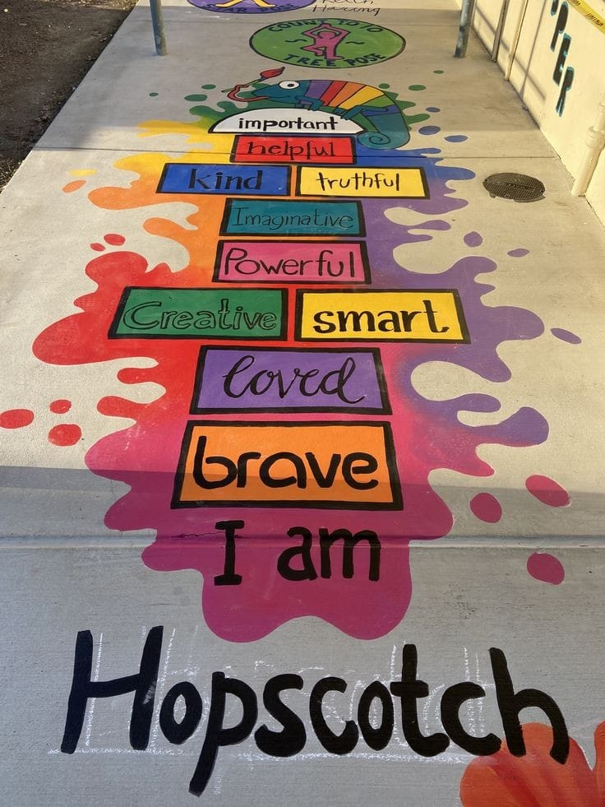

[**I am kind hopscotch - Bing images**](https://www.bing.com/images/search?view=detailV2&ccid=R96yXb2O&id=6012D85E6A57DE814913EC9885606BE29F4DCECA&thid=OIP.R96yXb2OKCHCDlu146TuWQHaJ3&mediaurl=https%3A%2F%2Fenchantedseashells.files.wordpress.com%2F2022%2F10%2F307754235_3388209244758144_1614653564606879230_n.jpg&cdnurl=https%3A%2F%2Fth.bing.com%2Fth%2Fid%2FR.47deb25dbd8e2821c20e5bb5e3a4ee59%3Frik%3Dys5Nn%252bJrYIWY7A%26pid%3DImgRaw%26r%3D0&exph=981&expw=736&q=I+am+kind+hopscotch&simid=608006583289319387&form=IRPRST&ck=4F2CD59865A31BDF3F57F20110DCAA15&selectedindex=0&ajaxhist=0&ajaxserp=0&pivotparams=insightsToken%3Dccid_fMPlxnE0*cp_9213EA10DDEE0D6A745F10608EB97033*mid_27C343E413A76ED55A2381C2D9A4579B871BED80*simid_608022478949608321*thid_OIP.fMPlxnE0Scw!_InF4Eyr3YgHaJ3&vt=0&sim=11&iss=VSI&ajaxhist=0&ajaxserp=0)

**New Business:**

* **Welcome new members:** Noella shared information about the demographics of the school. This year they have 19 teachers, 12 Educational assistants, 235 students, 14 classes, 1 Behaviour Intervention Mentor, Guidance (0.5), 1 Academic Support Teacher, 1 vice-principal & 1 principal  
  Noella has decided to retire at Christmas time after a successful career in education. She will be missed!

Teaching tools being used this year: Math Improvement Project, Social/Emotional Learning, Early Grades Literacy Assessment, & Holistic Curriculum

* **Budget discussion/ideas:** The committee has apx. $800 to spend as a committee. Jolene shared the list of approved expenses.
  + One idea was to look at the calming spaces within the school and see if there was anything that could be added.
  + There is a military deployment in December. Some children have already expressed sadness. Brittany will check with her MFRC contact to see if they are offering something to families involved with the deployment that could be shared with Gesner. Another idea was to host an open gym where students could come and have something to look forward to and parents could come to have coffee.
* **Update on changes to Policy 713:** Jolene shared a brief overview of the changes and encouraged members to reach out if anyone had any questions or concerns.
* **School Plan Training – Thomas:** There is no new information about this.
* **Schedule meetings for the year:** Meetings will be onTuesdays at 6 pm.

The following dates were proposed & accepted:

* October 17th
* November 14th
* January 16th
* February 13th
* April 9th
* May 14th
* June 11th

**Correspondence:** n/a

**Closing Comments:** Jolene thanked everyone for coming to the first meeting – it’s so great to have so many parents engaged in the committee.

**Date of Next Meeting:** October 17th at 6 pm

**Adjournment:** 7 pm